API Development and Integration Report
Date | 27-06-2025
Team ID | LTVIP2025TMID47711
Project Name | Project - HouseHunt

Project Title: HouseHunt
Date: 27-06-25

Objective
The objective of this report is to document the API development progress and key aspects of the backend services implementation for the HouseHunt project.

Technologies Used
- Backend Framework: Node.js with Express.js
- Database: MongoDB
- Authentication: JWT (JSON Web Token)

Project Structure
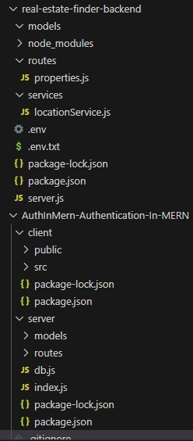

Key Directories and Files
- /controllers
  - Contains functions to handle requests and responses.
- /models
  - Includes Mongoose schemas and models for MongoDB collections.
- /routes
  - Defines the API endpoints and links them to controller functions.
- /middlewares
  - Custom middleware functions for request processing.
- /config
  - Configuration files for database connections, environment variables, etc.
6. /services
- Contains external service integration logic, such as the Street Map API.

API Endpoints
A summary of the main API endpoints and their purposes:
User Authentication
- POST /api/user/register - Registers a new user.
- POST /api/user/login - Authenticates a user and returns a token.
User Management
- GET /api/user/- Retrieves user information by ID.
- PUT /api/user/- Updates user information by ID.
Workout Plans
- GET /api/workoutplans - Retrieves all workout plans.
- POST /api/workoutplans - Creates a new workout plan.
Equipment
- GET /api/equipment - Retrieves all equipment.
- POST /api/equipment - Adds new equipment.
Monthly Plans
- GET /api/monthlyplans - Retrieves all monthly plans.
- POST /api/monthlyplans - Creates a new monthly plan
Street Map Integration
- GET /api/streetmap - Retrieves map data for specified locations using the Street Map API.
- POST /api/streetmap - Fetches and stores new map data from the Street Map API.
.
Integration with Frontend
The backend communicates with the frontend via RESTful APIs. Key points of integration include:
- User Authentication: Tokens are passed between frontend and backend to handle authentication.
- Data Fetching: Frontend components make API calls to fetch necessary data for display and interaction.
Error Handling and Validation
Describe the error handling strategy and validation mechanisms:
- Error Handling: Centralized error handling using middleware.
- Validation: Input validation using libraries like Joi or express-validator.
Security Considerations
Outline the security measures implemented:
- Authentication: Secure token-based authentication.
Data Encryption: Encrypt sensitive data at rest and in transion

